2. DEMOGRAPHIC ANALYSIS

PURPOSE

Demographics is the statistical study of population trends based upon data such as housing age and size, household size and age distribution of occupants, school enrolment, density, and income.

The population and demographic characteristics of Culpeper County are important because these statistics reveal much about the direction that the County is headed with respect to the need for expanded county services, recreation, education, health care, law enforcement, fire protection, emergency services, solid waste, utilities and other county-wide services. The analysis provides important information to private sector decision-makers who are considering locating or expanding commercial or industrial enterprises within the county. Population and demographic changes are also important in assessing land use and what changes might need to be made to land use plans and the policies used in guiding the development of the county in respect to land use. The following sections examine the changes, which have occurred from 1970 to 2000 in terms of population growth and characteristics such as age, sex, education and race including population projection into the future. Finally, this analysis formulates a population planning range to assess the County’s ability to provide services in an efficient and economical manner.

POPULATION TRENDS

As shown on the following table, “Historic Population Trends In Culpeper County,” the population change was negligible until the 1950’s when the County began to expand. The growth rate that began in the 1950’s has continued and accelerated since the 2000 Census. According to U.S. Census figures Culpeper County experienced a 20.7 percent increase from 1960 to 1970; a 24.2 percent increase from 1970 to 1980; a 22.9 percent increase from 1980 to 1990, and a 23.3 per cent increase for the last census period.

Historic Population Trends In Culpeper County
1930 | 1940 | 1950 | 1960 | 1970 | 1980 | 1990 | 2000
13,306 | 13,365 | 13,242 | 15,088 | 18,218 | 22,620 | 27,791 | 34,262

Culpeper County actually declined in growth from 1940 to 1950 by approximately 1% but began an increase in population in subsequent census years. The County began its rise in population from 1950 to 1960, growing by 13.9%. Growth rates fluctuated incrementally from 1960 to 2000. Significantly, the steady growth rate of 2.0 to 2.4 percent has jumped to over 3.8 percent per year for the years 2001 – 2003.

In 1993, the United States Office of Management and Budget determined that Fauquier, Culpeper and Clarke Counties met the statistical criteria to be included in the Washington DC/Northern Virginia MSA. Growth in surrounding counties varied significantly from virtually no growth at all to exponential growth as shown in the charts and figures below.

Growth Rate in Surrounding Counties
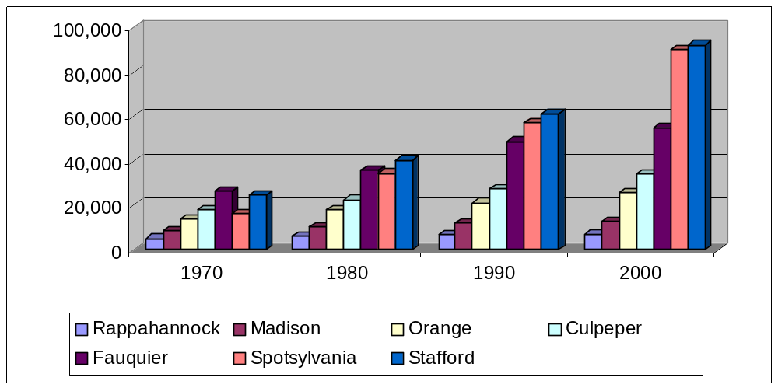

Growth Rates Per Census Data

 | 1970 | % | 1980 | % | 1990 | % | 2000
Culpeper County | 18,218 | 24.2 | 22,620 | 22.9 | 27,791 | 23.3 | 34,262
Fauquier County | 26,375 | 36.1 | 35,889 | 36.1 | 48,860 | 12.9 | 55,139
Madison County | 8,638 | 18.5 | 10,232 | 16.8 | 11,949 | 4.8 | 12,520
Orange County | 13,792 | 31.0 | 18,063 | 18.6 | 21,421 | 20.8 | 25,881
Rappahannock Co. | 5,199 | 17.2 | 6,093 | 8.7 | 6,622 | 5.5 | 6,983
Spotsylvania Co. | 16,424 | 109.7 | 34,435 | 66.7 | 57,403 | 57.5 | 90,395
Stafford County | 24,587 | 64.6 | 40,470 | 51.3 | 61,236 | 51.0 | 92,446

Comparatively, the Commonwealth of Virginia has grown at a fairly consistent rate since about 1940 of approximately 15 % per decennial census.
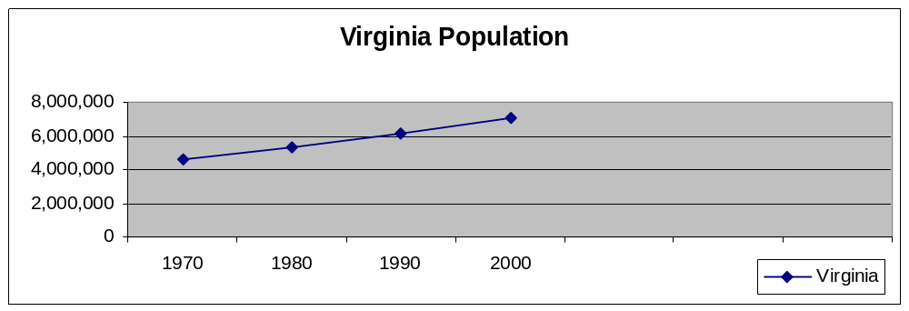
1970 | 1980 | 1990 | 2000
4,651,448 | 5,346,797 | 6,187,358 | 7,078,515

The population of the magisterial districts of Culpeper County is shown below along with the percentage of the population of the County. Magisterial districts, by State Code, are required to fall within certain population quotas of one another as voting districts. Culpeper County re-districted in 2001 to fall within the mandated guidelines. The following chart indicates district populations prior to redistricting.

Population of Magisterial Districts 2000
Catalpa | Cedar Mountain | East Fairfax | Jefferson | Salem | Stevensburg | West Fairfax
4,650 | 5,656 | 4,360 | 6,007 | 4,592 | 4,960 | 4,037

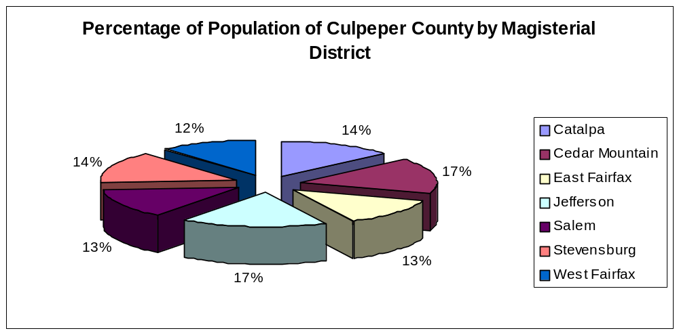

Percentage of Population Change 1990 to 2000
 | Catalpa | Cedar Mountain | East Fairfax | Jefferson | Salem | Stevensburg | West Fairfax
2000 Totals | 4,650 | 5,656 | 4,360 | 6,007 | 4,592 | 4,960 | 4,037
1990 Totals | 3,687 | 3,713 | 5,139 | 4,461 | 3,969 | 3,380 | 3,442
% Change | 26 | 52 | -15 | 35 | 16 | 47 | 17
(Based on U.S. Census Data)

The 2001 redistricting effort set a target district size of 4,895. Following the redistricting, the district sizes ranged from 4,811 to 5,089 persons.

POPULATION GROWTH: NATURAL INCREASE VERSUS NET MIGRATION

Natural increase (births minus deaths) and net migration (move-ins minus move-outs) are the two mechanisms of population change. In the 1980’s the County, like the State and nation, experienced a wave of births echoing the post war baby boom. In 1988, the Center for Public Service predicted that the echo was “likely to continue at least until the beginning of the [1990’s].”

For the past three decades, the majority of population growth in the County has resulted from in-migration. In the tables and charts shown above summarize the natural and migration population growth between 1970 and 2000.

For this planning period, population growth resulting from in-migration is likely to continue and constitute the substantial majority of residential increase. This increase derives from several factors:

- The continuing suburbanization of the metropolitan Washington, DC statistical region.
- The increased development in the Northern Virginia region.
- As employment opportunities in the Washington Metropolitan area increase, commuting remains a viable option.
- Although housing prices have appreciated dramatically in the last few years, the cost of comparable housing continues to be lower in Culpeper than in more northern eastern counties.

RACIAL CHARACTERISTICS

The racial composition of Culpeper County has been examined in the following tables. The population changes for Whites, Blacks and Other Races are shown. The 2000 Census altered the measurement criteria slightly by altering the definition of race. The following definitions are the 2000 Census Bureau definitions of “Race.”

“Race”
A subjective term—not biological or physical differences— used to distinguish groups of people. In the decennial census, respondents select the race or races with which they most closely identify. As defined by the Office of Management and Budget (OMB), the racial categories in the 2000 Census were: White, Black/African American, American Indian or Alaska Native, Asian, Native Hawaiian/Other Pacific Islander, and “Some other race.” The 2000 Census was the first census that allowed respondents to select more than one racial category.

“Some other race”
For data product purposes, “Some other race” includes race responses not included in the “White,” “Black or African American,” “American Indian and Alaska Native,” “Asian,” or “Native Hawaiian and Other Pacific Islander” race categories. Respondents providing write-in entries such as multiracial, mixed, interracial, or a Hispanic/Latino group (for example, Mexican, Puerto Rican, or Cuban) are included in the “Some other race” category.

For the purposes of this Chapter, in order to establish some commonality, the 1980,1990 and 2000 Census racial abstract was simplified to White (alone), Black (being those of African descent), and Other (including all other races for all three decennial census years and those included in the 2000 Census under the heading of “two or more races).

During the decade between 1980 and 1990 the Black population increased in number by 130; whereas the White population increased in number by 4,647 or a 3% increase of Blacks compared to a 26% increase in Whites. Percentage-wise, Other races increased 876% during this decade but numerically by only 394. It may be noted that while the percentage of increase may appear to be extremely large, the numerical increase from 45 to 439 explains the high percentage of increase.

The percentage of the population of the County which was White in 1980 was approximately 79%, Black was approximately 21% and Other races was less than 0.2%. Growth patterns during 1980 to 1990 raised the White population percentage of the County to 81%, lowered the Black population to approximately 17% and raised the population of all Other races to approximately 2% of the total population.

The 2000 Census reported that the racial make up of Culpeper County changed but not significantly. The percentage of Whites dropped from 81% to 78 %. The Black percentage increased from 17% to 18%, and Other Races increased to 4% of the total population.

Percentage Of Racial Change in Culpeper County
 | 1980 | % Of Pop. | 1990 | % Of Pop. | 2000 | % Of Pop.
White | 17,922 | 79 | 22,569 | 81 | 26,816 | 78
Black | 4,653 | 21 | 4,783 | 17 | 6,220 | 18
Other | 45 | 0.2 | 439 | 2 | 1,226 | 4

According to the 2000 Census, using the criteria listed above, the racial characteristics of the magisterial districts are listed below.

Racial Characteristics by Magisterial District 2000 (Population)
 | Catalpa | Cedar Mountain | East Fairfax | Jefferson | Salem | Stevensburg | West Fairfax
Total: | 4,650 | 5,656 | 4,360 | 6,007 | 4,592 | 4,960 | 4,037
White alone | 4,094 | 3,692 | 2,926 | 5,355 | 3,884 | 3,632 | 3,233
Black alone | 481 | 1,763 | 1,153 | 525 | 570 | 1,076 | 652
2+ Races | 34 | 78 | 99 | 60 | 85 | 75 | 59
Other | 41 | 123 | 182 | 67 | 53 | 177 | 93

The chart below lists the percentages of Racial Characteristics for the Magisterial Districts shown in the graph above as taken from the 2000 Census.

Racial Characteristics by Magisterial District 2000
(Percentage of Population)
 | Catalpa | Cedar Mountain | East Fairfax | Jefferson | Salem | Stevensburg | West Fairfax
White alone | 88% | 65% | 67% | 89% | 85% | 73% | 80%
Black alone | 10% | 31% | 26% | 9% | 12% | 22% | 16%
2+ Races | 1% | 1% | 2% | 1% | 2% | 2% | 1%
Other | 1% | 2% | 4% | 1% | 1% | 4% | 2%

POPULATION BY AGE, RACE & SEX

The information in this section is an analysis of the age and sex of the population of Culpeper County for the period 1980 – 2000. Age groupings are bracketed in the following charts, entitled “Age, Race & Sex Characteristics ~ 1980 – 2000.” Note that in these charts the percentage of change in the “Other Race” designation may greatly exceed 100%. This occurs because a small numerical population increased by a comparatively small number often constitutes a high percentage of change. For example note that in the chart immediately below, the percentage of increase in the Other Race column is 185% for a numeric increase of only 120 total persons, male and female.

AGE, RACE & SEX CHARACTERISTICS
PERCENTAGE OF CHANGE FROM 1990 TO 2000

Pre-school Population ~ Under 5 Years Old
 | White |  |  |  | Black |  |  |  | Other
 | Total | Male | Female |  | Total | Male | Female |  | Total | Male | Female
1990 | 1,722 | 840 | 882 |  | 449 | 224 | 225 |  | 65 | 54 | 11
% Change | (5) | - | (10) |  | (17) | (20) | (15) |  | 185 | 74 | 727
2000 | 1,630 | 840 | 790 |  | 371 | 180 | 191 |  | 185 | 94 | 91

Over the last decade Culpeper County showed a decrease in the population of Pre-school individuals in both the White and Black populations with an increase of 120 individuals in the Other race population. The population of Pre-school individuals, which typically impacts the future with regard to school facility needs, housing, community facilities, and future population growth, is not a dynamic indicator of what the future needs may be according to current census data. The projected growth, listed in the charts below, will be determined by other factors including the current availability of housing and the increasing demand for housing in the County in the future.

School Age Population ~ 5 to 14 Years Old
 | White |  |  |  | Black |  |  |  | Other
 | Total | Male | Female |  | Total | Male | Female |  | Total | Male | Female
1990 | 3,243 | 1,708 | 1,535 |  | 795 | 432 | 363 |  | 56 | 29 | 27
% Change | 21 | 13 | 30 |  | 15 | 8 | 22 |  | 350 | 331 | 370
2000 | 3,926 | 1,937 | 1,989 |  | 911 | 468 | 443 |  | 252 | 125 | 127

The total School Age White population grew by 21% compared to a Countywide growth rate of 19% for all ages in the White population. The total School age Black population grew by 15% compared to a countywide growth rate of 30% for all ages in the Black population. The growth rate in these populations is significant numerically, gaining 683 white individuals and 116 black individuals. The increase in Other races is also numerically significant, an increase of 196 individuals. The increases are calculated from all ages combined.

High School – Working Age Population ~ 15 to 54 Years Old
 | White |  |  |  | Black |  |  |  | Other
 | Total | Male | Female |  | Total | Male | Female |  | Total | Male | Female
1990 | 12,771 | 6,380 | 6,391 |  | 2,710 | 1,337 | 1,373 |  | 285 | 139 | 146
% Change | 19 | 21 | 17 |  | 42 | 72 | 13 |  | 140 | 159 | 122
2000 | 15,185 | 7,725 | 7,460 |  | 3,850 | 2,301 | 1,549 |  | 684 | 360 | 324

The total High School - Working Age White population grew by 19% compared the total High School – Working Age Black population which grew by a much higher 42%. The growth rate in these two populations remain significant numerically in that the White population grew by 2,414 and the Black population by 1,140 individuals. The growth increase in Other races is also significant, an increase of 399 individuals.

Pre-retirement Age Population ~ 55 to 64 Years Old
 | White |  |  |  | Black |  |  |  | Other
 | Total | Male | Female |  | Total | Male | Female |  | Total | Male | Female
1990 | 1,844 | 889 | 955 |  | 438 | 221 | 217 |  | 30 | 15 | 15
% Change | 45 | 52 | 38 |  | 9 | 8 | 11 |  | 80 | 80 | 80
2000 | 2,672 | 1,350 | 1,322 |  | 478 | 238 | 240 |  | 54 | 27 | 27

The total Pre-retirement Age White population grew significantly, by 45%. The total Pre-retirement Age Black population grew only 9%.

Retired – Elderly Population ~ 65 Years Old and Over
 | White |  |  |  | Black |  |  |  | Other
 | Total | Male | Female |  | Total | Male | Female |  | Total | Male | Female
1990 | 1,844 | 889 | 955 |  | 438 | 221 | 217 |  | 30 | 15 | 15
% Change | 45 | 52 | 38 |  | 9 | 8 | 11 |  | 80 | 80 | 80
2000 | 2,672 | 1,350 | 1,322 |  | 478 | 238 | 240 |  | 54 | 27 | 27

The total Retired - Elderly White population grew by 45% compared to a Countywide growth rate of 19% for all ages in the White population. The total Retired - Elderly Black population grew by 8% compared to a countywide growth rate of the total Black population of 30%. The growth increase in Other races is an increase of only 24 individuals. The difference between White and Black, ages 15 – 54 changes from 1990 to 2000 tends to indicate a strong in-migration of childless Black individuals.

TOTAL POPULATION PERCENTAGE OF CHANGE BY SEX & AGE

The charts listed below reinforce the section above in showing both the numbers of males and females in the respective age groups along with the percentage of the total population. Also noted in these charts is the percent of change through the decennial census years 1980, 1990 to 2000.

Rankings of the age groups by population and percentage of the total population are as follows:
- High School – Working Age Population 15 to 54 Years Old
- School Age Population ~ 5 to 14 Years Old
- Retired – Elderly Population ~ 65 Years Old and Over
- Pre-retirement Age Population ~ 55 to 64 Years Old
- Pre-school Population ~ Under 5 Years Old

As would be expected, the highest population and percentage of the total population is the High School Working - Age Population, simply because it cover the largest range of ages from 15 to 54 years old.

Pre-school Population ~ Under 5 Years Old
 | All Races |  |  |  |  | %of Population
 | Total | Male | Female | Total % |  | Male | Female
1980 | 1,615 | 793 | 822 | 7.14 |  | 3.51 | 3.63
% Change | 38 | 41 | 36
1990 | 2,236 | 1,118 | 1,118 | 8.05 |  | 4.02 | 4.02
% Change | (2) | (0) | (4)
2000 | 2,186 | 1,114 | 1,072 | 6.38 |  | 3.25 | 3.13

School Age Population ~ 5 to 14 Years Old
 | All Races |  |  |  | %of Population
 | Total | Male | Female | Total % | Male | Female
1980 | 3,732 | 1,903 | 1,829 | 16.50 | 8.41 | 8.09
% Change | 10 | 14 | 5
1990 | 4,094 | 2,169 | 1,925 | 14.73 | 7.80 | 6.93
% Change | 44 | 17 | 33
2000 | 5,889 | 2,530 | 2,559 | 17.19 | 7.38 | 7.47

High School – Working Age Population ~ 15 to 54 Years Old
 | All Races |  |  |  | %of Population
 | Total | Male | Female | Total % |  | Male | Female
1980 | 12,217 | 6,186 | 6,031 | 54.01 |  | 27.35 | 26.66
% Change | 29 | 27 | 31
1990 | 15,766 | 7,856 | 7,910 | 56.73 |  | 28.27 | 28.46
% Change | 25 | 32 | 18
2000 | 19,719 | 10,386 | 9,333 | 57.55 |  | 30.31 | 27.24

Pre-retirement Age Population ~ 55 to 64 Years Old
 | All Races |  |  |  | %of Population
 | Total | Male | Female | Total % | Male | Female
1980 | 2,201 | 1,152 | 1,049 | 9.73 | 5.09 | 4.64
% Change | 5 | (2) | 13
1990 | 2,312 | 1,125 | 1,187 | 8.32 | 4.05 | 4.27
% Change | 39 | 44 | 34
2000 | 3,204 | 1,615 | 1,589 | 9.35 | 4.71 | 4.64

Retired – Elderly Population ~ 65 Years Old and Over
 | All Races |  |  |  | %of Population
 | Total | Male | Female | Total % | Male | Female
1980 | 2,855 | 1,692 | 1,163 | 12.62 | 7.48 | 5.14
% Change | 18 | (21) | 76
1990 | 3,383 | 1,334 | 2,049 | 12.17 | 4.80 | 7.37
% Change | 20 | 30 | 13
2000 | 4,064 | 1,740 | 2324 | 11.86 | 5.08 | 6.78

TOTAL PUBLIC SCHOOL ENROLLMENT

The table below shows the public school enrollment as a percentage of the total population over the past four decennial censuses. Only students in the County public schools are counted. Further discussion of the public school population projections and facilities is found in Chapter 6.A Public Facilities.

Culpeper County Public School Enrollment

 |  | County |  | Public School |  | Percent of
School Year |  | Population |  | Enrollment |  | Population
1970 |  | 18,218 |  | 4,675 |  | 25.66
1980 |  | 22,680 |  | 4,600 |  | 20.28
1990 |  | 27,791 |  | 4,892 |  | 17.60
2000 |  | 32,262 |  | 5,627 |  | 17.44

Sources: U.S. Census, Culpeper School Dist.

POPULATION PROJECTIONS

A twenty year term, from 2000 to 2020, was chosen to provide the framework from which to estimate future population growth, capital improvements and private development. A number of techniques were used to estimate the population trends, the most relevant and/or realistic future population trends and most realistic future population projections were then chosen. Comparing those estimates with development trends and County building permits issued over the last several years provides a range of future population projections based upon current growth patterns.

Several existing sources were considered in formulating these population projections. Those sources included the Virginia Employment Commission (VEC), NPA Data Services, and the Weldon-Cooper Center for Public Services. The VEC projections are based on national and local economic trends. The methodology utilized by NPA was not noted. The Weldon-Cooper Center is a cohort survival projection based on local birth and death rates. The in-migration, people moving into Culpeper County, is significantly underestimated by the sources listed above. They are included in the study to demonstrate a range of future population projections based upon a variety of available sources.

2000 2010 2020
Population (Census) 34,262
V E C 41,000 48,000
NPA Data Services 40,310 45,000
Weldon-Cooper Center 37,503 43,000

The most recent US Census (July, 2004) population data of 39,100 shows the above projections to be clearly outdated. In fairness, all were prepared prior to the growth increases occurring since 2000.

To find a more realistic methodology for projecting the future growth of Culpeper County three methods were used based on existing data: the historical projection of a growth rate of about 23% per decennial reference; a projection based upon the Census data from April, 2000 to July, 2003; and development trends tracked through issuance of building permits.

- The first method of projection utilized was the average growth rate taken from previous census years, approximately 23% per decennial period, projected forward for 2010 and 2020. the results are as follow:

2000 2010 2020 Projected Average Growth: 34,262 42,142 51,834

- In April 2004, the U.S. Census Bureau published its population estimates of the 100 fastest growing counties in the United States, rating Culpeper County as number 87 in the entire country. The data extended from April 1, 2000 to July 1, 2003, stating that by July 1, 2003 Culpeper County had grown to an estimated population of 38,555 or an increase of 4,293 or 12.5% in 3.25 years. Using that data, the population would increase by 3.85% per year.

For the purposes of projecting the population for 2010and then 2020, that growth rate of 3.85% per year was held as most likely.

2010 2020
Projection based on most recent U.S. Census Data: 50,225 73,280

- In an effort to estimate the impact of continued in-migration, an unchanged growth driven economy and continued development and housing starts, a projection was made based upon building permits issued from 2000 – 2004 for all dwelling units. The projection accounts for household size, estimated by Census data to be 2.68 persons per household and a level increase of 1,732 persons per year from 2003 to 2010 with a slight down turn from 2010 to 2020.
2010 2020
Projection Based on 2000-03 Building Permits: 50,676 65,676

- Based upon the influx of new residents to Culpeper County, current thriving economic and housing trends, and the increase in building permits issued over the last few years, the projection above is a low-end projection. It follows that an adjusted projection is needed to accommodate the rise in the issuance of building permits over the last few years. The Adjusted Building Permit Projection below is based upon building permits issued from 2000 to 2004, with adjustments made for a decreasing household size, as a general trend, and a slight down turn in the rate of growth in the decade between 2010 and 2020. Note that based upon 2000-2004 building permit activity, the annual growth rate between 2004 and 2010 exceeds 4%.

2010 2020
Adjusted Building Permit Projection: 52,960 71,867

Population projections serve to estimate demographic trends, prescribe future needs, and facilitate the planning process. These projections are not finite, nor are they especially predictable depending upon changing market forces. Projections are based on the data currently used at the time of calculation, and as such, demographic analyses must change with time. The adjusted building permit projection is currently seen as most likely.

GRAPHIC REPRESENTATIONS

Population Projections
 | 1980 | 1990 | 2000 | 2010 | 2020
Census | 22,620 | 27,791 | 34,262
Weldon-Cooper |  |  |  | 37,503 | 43,000
NPA Data Services |  |  |  | 40,310 | 45,000
V E C |  |  |  | 41,000 | 48,000
Historical Projection |  |  |  | 42,142 | 51,834
US Census ~ % |  |  |  | 50,225 | 73,280
Bldg. Per. '00-'04 |  |  |  | 50,676 | 65,676
Bldg Permits Adj. |  |  |  | 52,960 | 71,867



